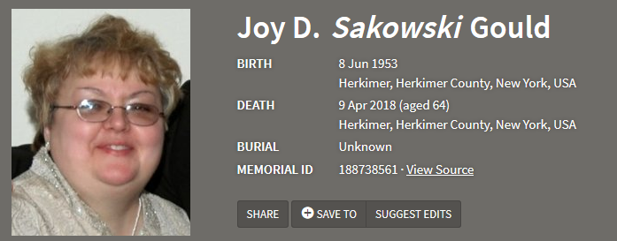

Joy D. Gould, 64, passed away Monday April 9, 2018.
She was born on June 8, 1953 in Herkimer, NY a daughter of the late Stanley & Olga (Banach) Sakowski.
She was a graduate of Herkimer High School, Class of 1971 and went on to attend HCCC, and then received her degree from Oneonta State. Joy taught 4th grade at Oppenheim Ephratah Central School for many years. She loved to tend to her gardens and to shop! She is survived by her son and daughter-in-law, Erik K. Gould (Katie) of Herkimer and her brother and sister-in-law, David Sakowski (Patricia) of Greece, NY. Joy’s world revolved around her beloved grandchildren, Kayla and Erik. She also leaves many aunts, uncles, nieces and nephews.

